**The Design Journey of Staffjoy V2**

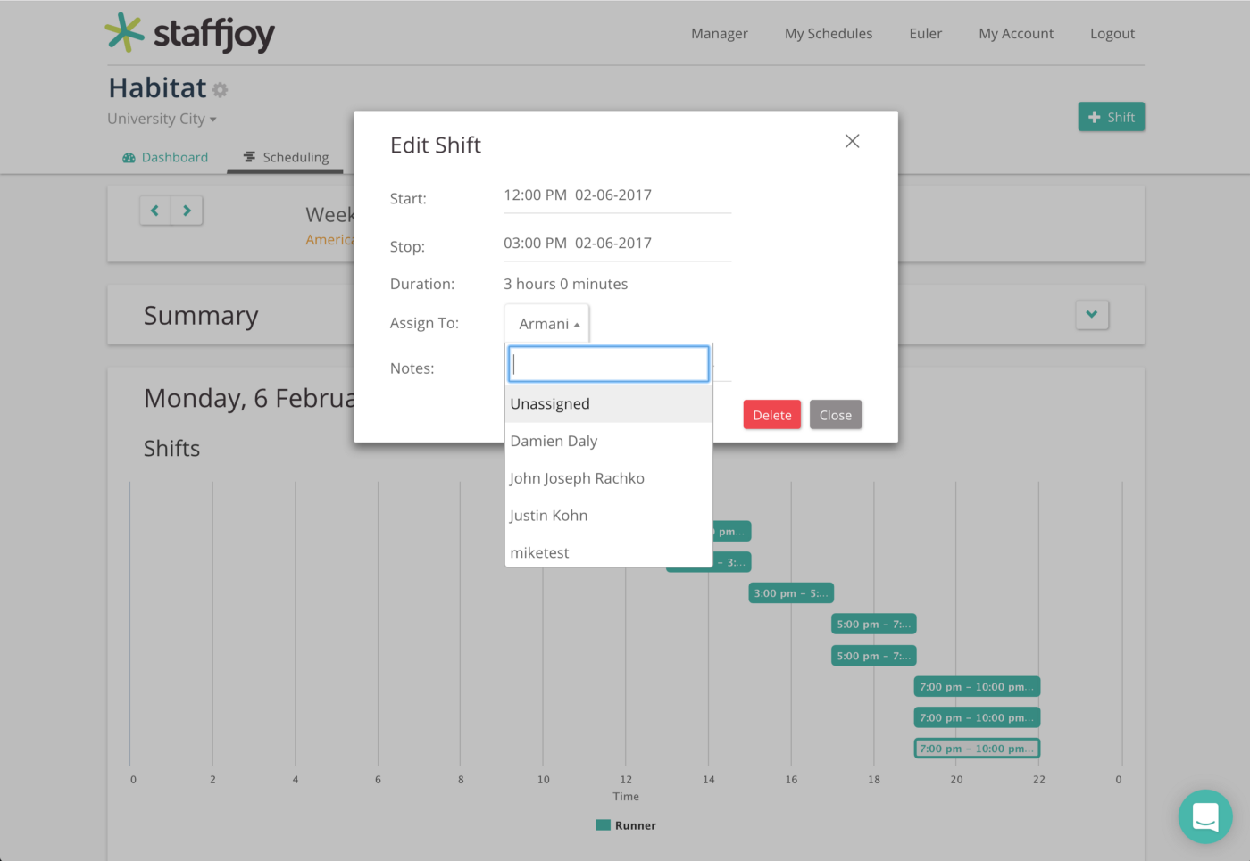

Staffjoy V1 had advanced features like automated scheduling and recurring shifts, but users had a hard time with basic functions of the app.

**Background**

I joined Staffjoy as a full-time product designer in July 2016. The timing could not have been more perfect. The team decided to rebuild the app from the ground up for two main reasons:

* Users weren’t able to do simple things like enter employee info, or manually create a schedule without reaching out for tech support
* We received tons of helpful feedback, but the engineering systems in place required a lot of time to implement these changes

This gave me the opportunity to conduct the necessary user research and testing to make sure we could build Staffjoy to be easy to use and master for our users going forward.

**Redesign Goals**

* Target small business owners running restaurants, cafes, and coffee shops, etc.
* Get business owners and managers off of paper/pencil and Excel sheets.
* Improve communication between employer and employees to handle missing and picking up shifts.

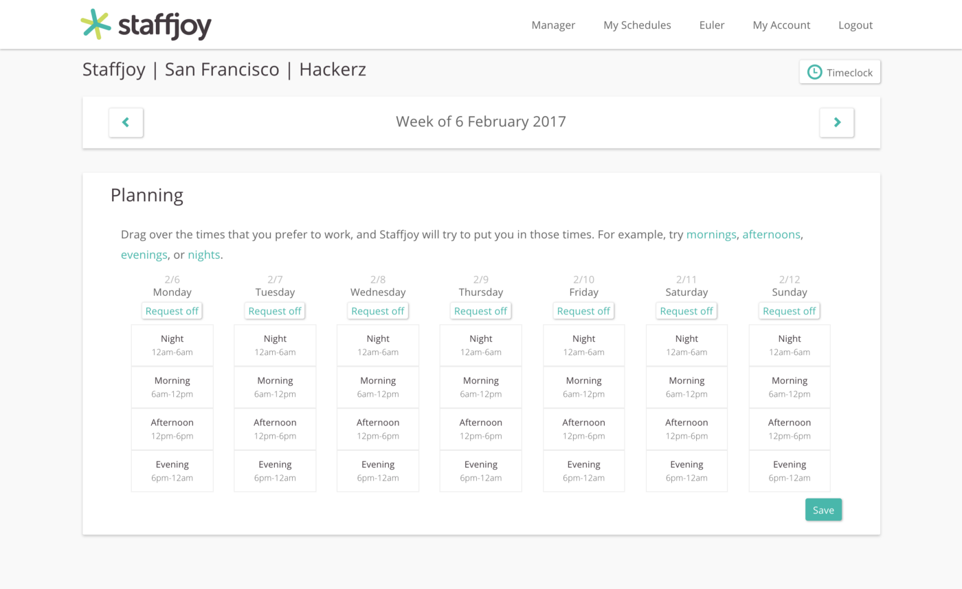

It was a long process to build out a feature like time off requests in V1.

**User Research**

In my first two weeks at Staffjoy, very little wireframing was done. We needed to get out there and talk to people working in the food and service industry. Luckily, Staffjoy’s office is located near a bunch of local businesses and along with a little Craigslist help, we talked to more than 10 managers and employees that week.

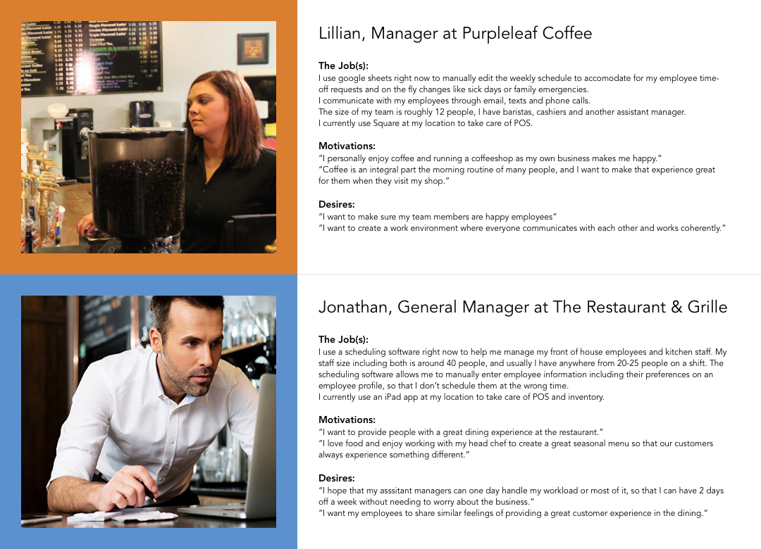

I created user stories based off our research and conversations with managers and employees.

**Design & Code**

One of the business problems we looked to solve with rebuilding our product was insuring our engineering architecture would allow long term improvements over time. For more intricate details of V2 architecture, Staffjoy’s CEO, Philip, wrote all about it [here](https://blog.staffjoy.com/staffjoys-v2-architecture-9d2fcb4015fd#.83infutr9).

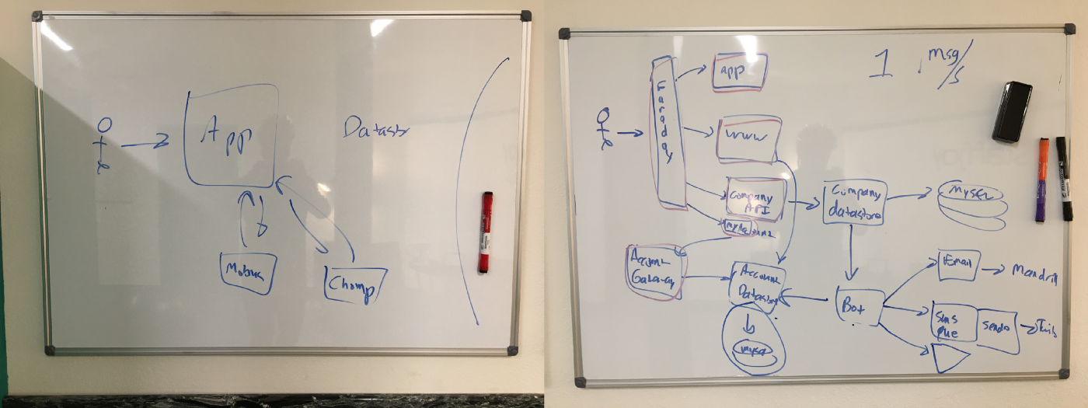

Here was my visual understanding of the architectural improvements being made in terms of how Staffjoy handles “a bunch of servers talking to each other, but still keeping information private.”

**Wireframes & Prototypes**

One of the main goals of redesigning Staffjoy was:   
“Get business owners and managers off of paper/pencil and Excel sheets.”

The visual and UI design to complement this goal was to create a grid and utilize card design for individual shifts that would allow easy adjustments to accommodate for last minute changes.

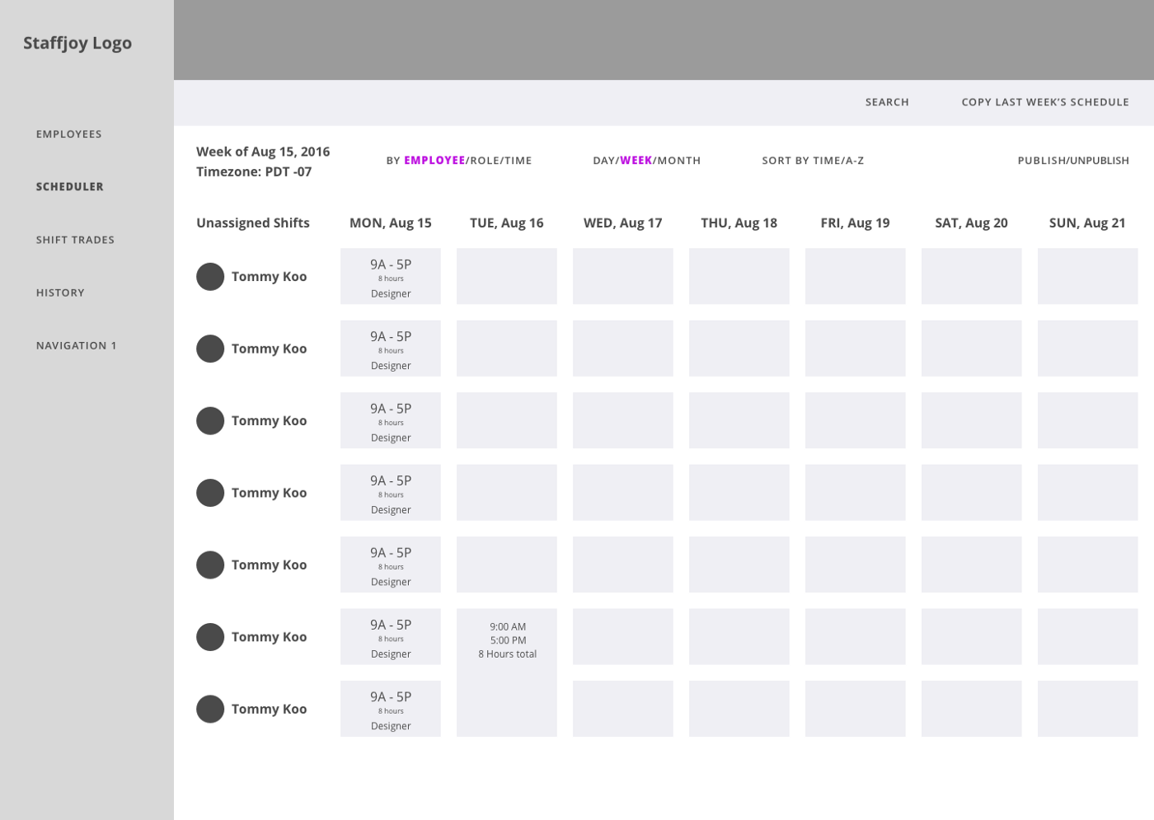

Started out with a basic side navigation and dashboard-like interface

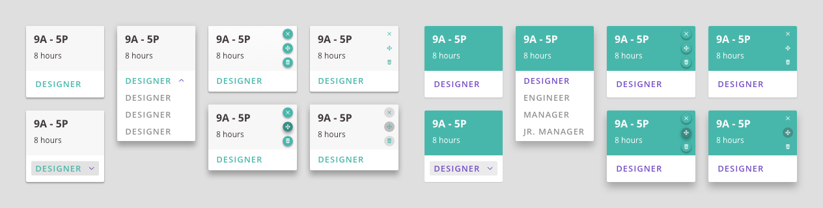

An early look at shift cards that include information at a glance for hours and job. Think of them like Post-its with an edit button… that you don’t have to throw away day by day. RIP Trees.

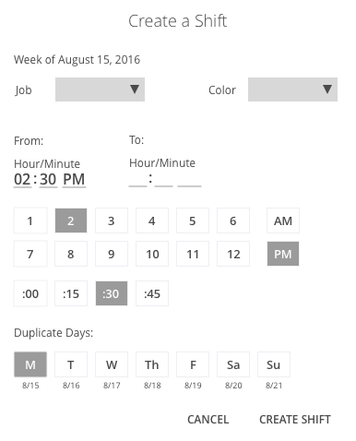

Modal window for creating a new shift. I tested this with users to judge what information to display together and what to separate across different progress points in shift creation.

After a few more iterations, I created the scheduling interface utilizing the shift cards and it was ready to go to engineering to be implemented.

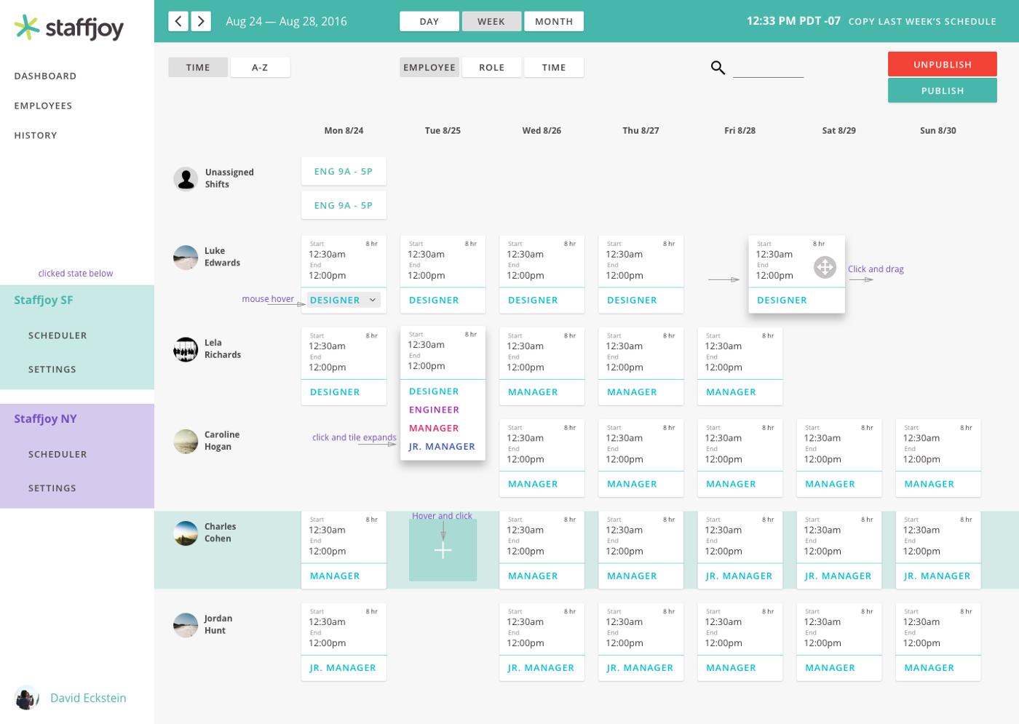

A lot of notes on the screen to describe interactions of dragging and dropping cards and how the drop down menu worked to change the employee roles.

**Solving the Communication Problem**

In our interviews with managers and employees, we began noticing a pattern that added to both employer and employee stress when scheduling shifts for the weeks to come.

* Not everyone who works in this industry uses a smartphone. They might not even have an email they regularly check.
* Store managers had to manually contact their staff if last minute changes were made.

Staffjoy V1 utilized a text bot previously to remind workers when their shift started and ended to remind them to clock in and out. We expanded on this further and improved the functionality so that managers no longer have to manually send texts or emails to employees. The messages would include the weekly schedule and also update employees anytime changes were made to their shifts.

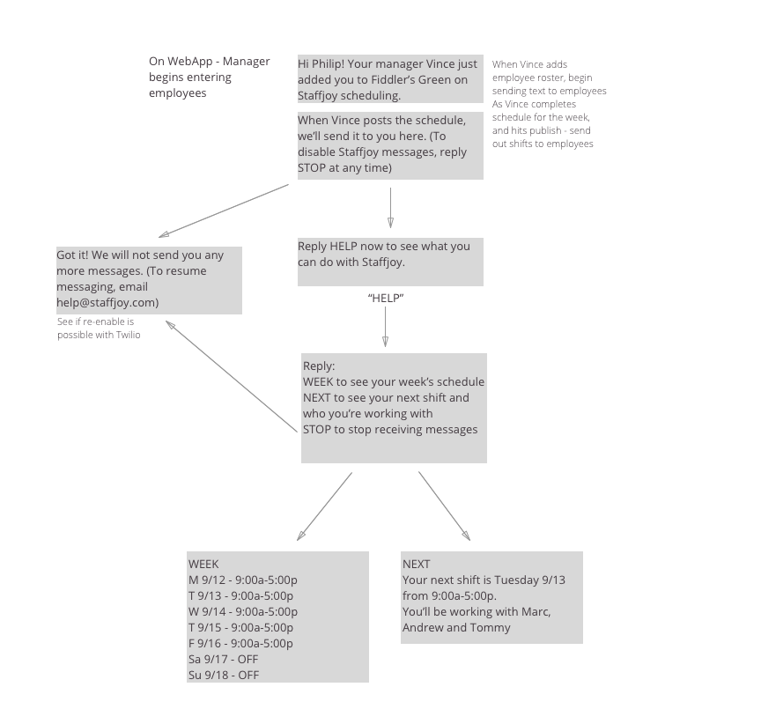

One of our early SMS messaging workflows to handle interacting with Staffjoy’s text bot.

**What It Looks Like Currently**

Well I could play show-and-tell here, or you can check out [www.staffjoy.com](http://www.staffjoy.com) and make a free trial account to play around with.

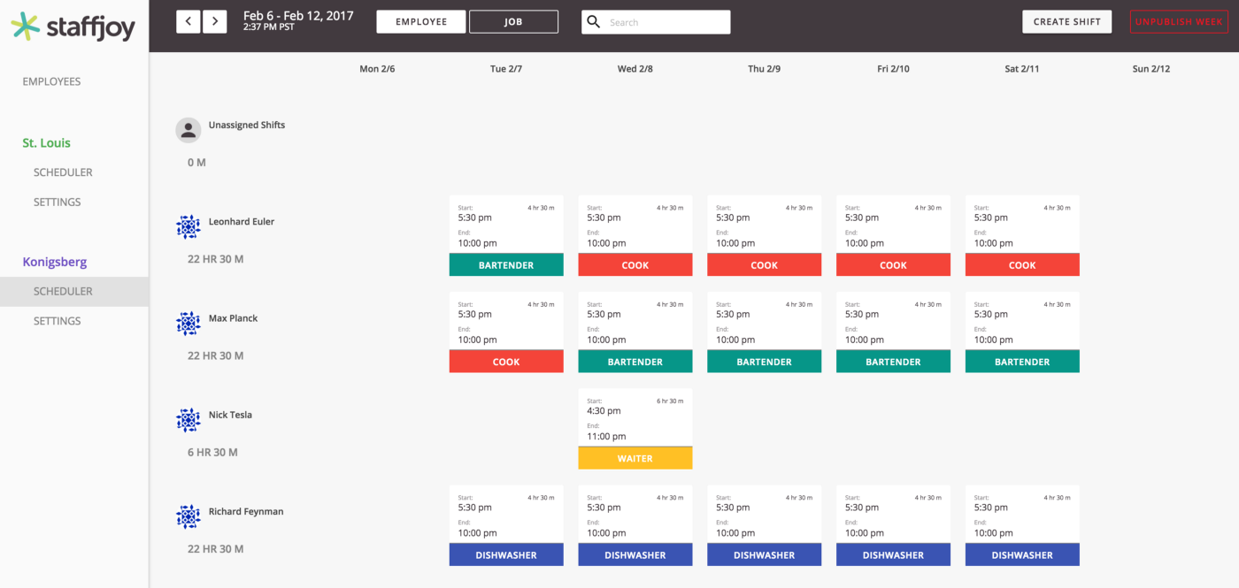

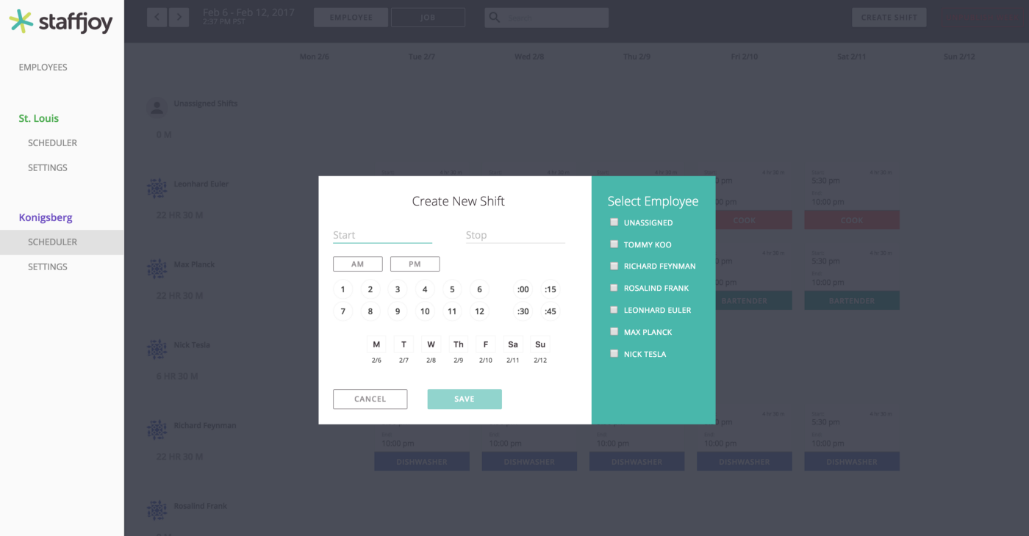

Thank you for reading about my journey (so far) at Staffjoy!

If you and/or any loved ones run a small business, I’d love to hear about your experience with technology you’ve tried that has improved your business!